Date: 30 March
Time: 11am – 2pm
Place: Buckingham palace

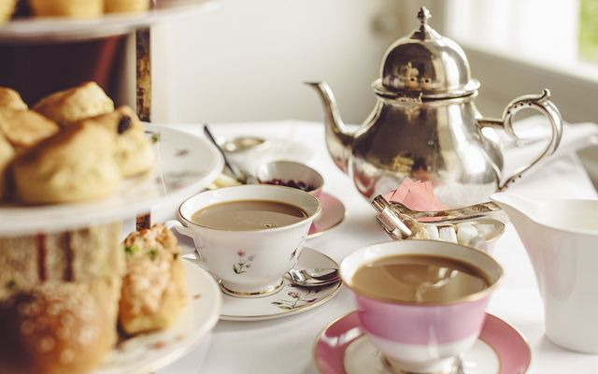
Tea Ceremony
Dear friend, I am pleased to announce that in three weeks will be a tea ceremony in Buckingham Palace. It will be attended by a large number of guests: politicians, ministers, members of the royal family and reporters. I would be delighted if you could attend the tea ceremony, we will discuss the subtleties of the tea ceremony and have a wonderful time.

