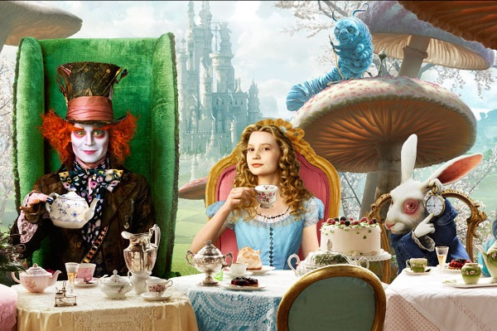
TEA TIME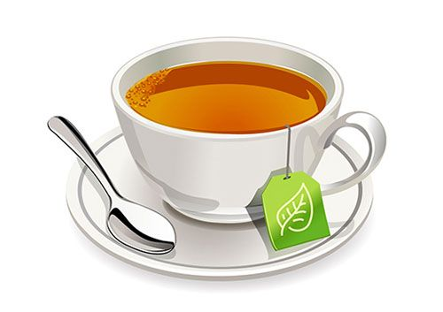

My dear friends!
Three times a year I open my private gardens in Buckingham Palace to the public: more than 8,000 guests arrive at the courtyard for a traditional tea party. An invitation to reception is received by completely different people: officials, military, representatives of charitable organizations.
And I would like to invite you. We will plunge into the fabulous atmosphere of the traditions of England. My servant will teach you how to make tea and drink it properly.
Time: 10am - 4pm
Date: May 31, 2020
